KRC pitfall trapping metadata

Experimental design: We set up 100 bases for pitfall traps in 3 sites distinguished by different land-use types: KRC [natural], Johnny’s North [low grazing/browsing intensity], Johnny’s South [moderate to high grazing/browsing intensity] – although grazing/browsing regimes are more dynamic, determined by rotational schedules. In each of the sites, we randomly laid out 3 transects along an elevation gradient, starting on a higher elevation dune and going downslope (+ an additional transect on big dune at KRR). The direction of the transects were always north to south. Along each transect, we set up 10 pitfall trap bases. The transects were 180 m in length, and every 20 meters, we set up a base of the pitfall trap as follows: We dug a ca. 40 cm deep hole, positioned a bucket in the hole (25 cm in diameter), ensuring that the top of the bucket is at ground level, and covered the bucket with a lid.

Data collection: At each of the 100 locations, at set up and every 4-6 months thereafter, we determined the vegetation composition in a 4x4 m quadrat, considering the pitfall trap base as the center. We recorded % bare soil cover, % grasses, % shrubs, % trees, and average height of the vegetation (cm). We also recorded all the species. If a tree was juvenile and grew in bushy, we considered it as part of the shrub cover. More info on the variable collected can be found in the metadata of vegetation_transects.xlxs.

Initially, every 14 days, we established intensive pitfall trap monitoring for 48 hours. We started the monitoring at 7:00 h at a randomly chosen transect, where we positioned 10 buckets with funnels inside the bases, starting with the northern-most base. We ensured that the traps were at ground level (no gap between trap and soil) while minimizing perturbations to the soil. We repeated this at the closest transect until all traps were set. We collected the insects inside the traps every 4 hours during the day (until 19:00), and left the traps overnight (19:00 – 7:00). We morphologically determined all trapped invertebrates at least to the family level (and species level wherever possible), and weighted all samples.

Due to logistic constraints, we will split the 48-h monitoring into two areas and we reduced the sampling to 24 h after September 20, 2023.

1st week: big dune D15, H15, K18, Q17, P15
2nd week: J13, J15, L15, L17, O18

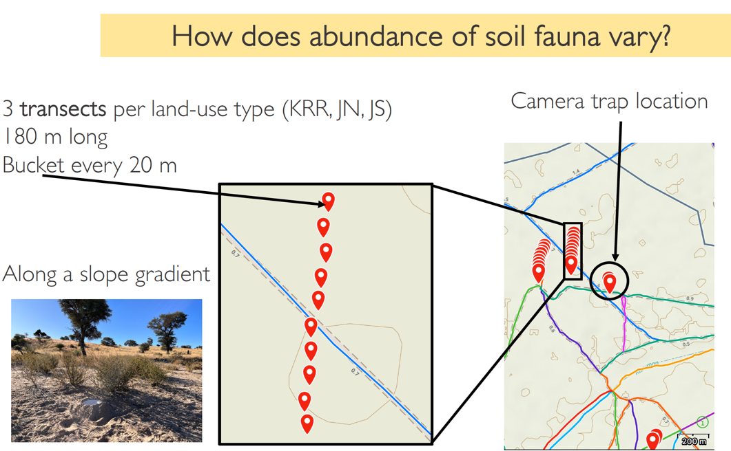

Data files:

We recorded the location of each base, which can be found in transects.kml. Each location is named after the closest camera trap location name, followed by the base number (1-10) along the north-south transect line (L).

We recorded the vegetation composition at each of the 100 pitfall trap locations in vegetation_transects.csv.

